• The valence band and the conduction band meet at Dirac point

– Metallic behavior

– “Semi‐metal” or “zero‐bandgap semiconductor”

• Linear E‐k dispersion near Dirac point

– “Massless” electrons and holes

• Most of doping methods could considerably damage carrier mobilities of graphene.

• The doping level could not easily be controlled.

• The doping devices are very vulnerable to environment, especially for n‐type doping.

• Zero effective mass near the Dirac point

• High carrier mobility >15,000 cm2/ V‐1s‐1

• Low Resistivity about 10‐6 Ω∙cm, (< siliver)

• One atomic layer absorption = pi \* alpha = 2.3%

• High transparency

• extremely high value of the thermal conductivity

Synthesis of Graphene

• Mechanical exfoliation (by using tape)

• Epitaxial growth on silicon carbide (CVD)

• Epitaxial growth on metal substrates (z.B. Cu)

• Reduction of graphene oxide

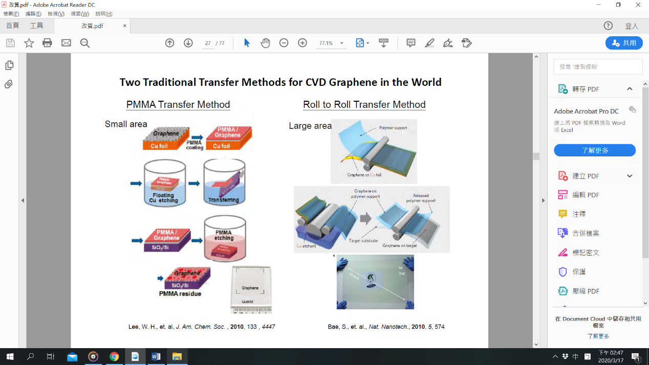=> solution processible, mass producible, simple and cheap

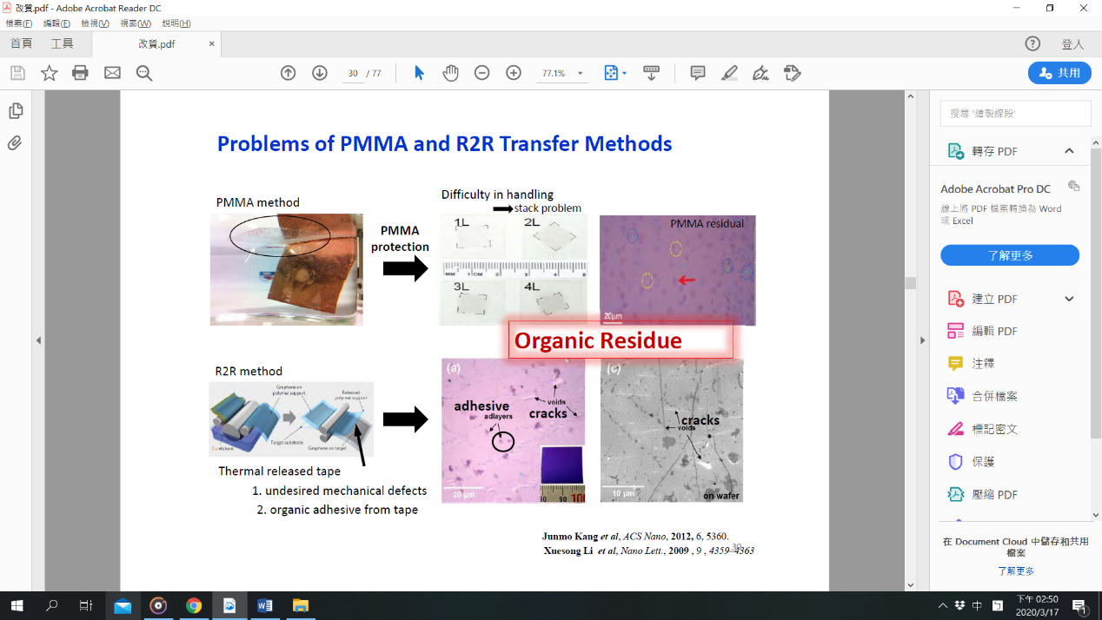

Clean Lift Transfer (CLT) : remove residue on large area graphene film

• Effects on transport properties

* Charge impurity ( doping, absorbate )
* Intrinsic defect ( grain boundary, dislocation )
* Suface roughness ( substrate )
* Environment condition ( atmosphere, dielectric )
* Photon scattering ( temperature )

